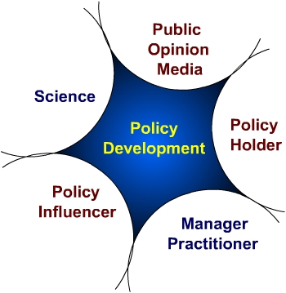  Policy – What is it?  - Public consensus on how we live together  - A decision or direction made by people in positions of authority  - It is articulated and codified  - It is not an event – rather, it emerges over time  - Policy is not policy until it is implemented  Who are the Players in Policy Development?  There are five major players typically involved with policy development:  - Policy holders – these people draft and debate policy and often vote on policy  - Manager/Practitioner – often concerned with the feasibility and impact of policy  - Policy influencers – those with a stake in the policy  - Science – contribute evidence to policy development process  - Public Opinion and the Media- public opinion reflects widespread social norms. The media reflect and lead public understanding, and influence policy holders.  The label colors imply more similar cultures, and therefore easier communication. | Evidence and Public Policy Development  Five Models (Carol Weiss, 1979/1998)  Knowledge Driven Model  New knowledge from research creates pressure for policy development – a seamless transfer of new knowledge into policy.  Typically rare – only exists when there is consensus & no controversy.  Example: Child car seat legislation.  Problem Solving Model  Evidence from several sources is used as a starting point, in a rational iterative process that has a defined beginning and end. Evidence is valued as a primary driver for policy development  Example: Protecting children from secondhand smoke.  Interactive Model  Research, along with experience, political insight and social pressure are used for policy development.  Example: Provincial tobacco control legislation  Political Model  Evidence is used to justify a predetermined position – sometimes data are selectively included.  Example: Eugenics legislation  Tactical Model  Evidence is used to delay/avoid an unpopular decision  Normal uncertainty of research is used as a delay tactic  Example: Child Care Funding  Minimum Wage  The last three models are most often encountered. | The Importance of Culture  The language, ritual and stories of those involved in the policy development process are critical to understand. These ‘tip of the iceberg’ items reflect the culture, and provide clues to meaningful and sustained communication.  Consider the world of the researcher-  Very rigorous and controlled environment - rituals of peer review and research days- curiosity driven research - milestones are discoveries (e.g. islet cell transplantation) – rewards related to publishing in peer reviewed journals and the ability to access funding – tradition of scientific caution, and communicating through highly specialized mechanisms.  Consider the world of the politician-  Dynamic, constant change – information often anecdotal – stories are used to convey information – milestones are relationship-based – rewards are related to ability to influence others and to get re-elected – communication often informal and via non-traditional routes. | Risk Tolerance for Using and Losing Political Currency  As policy development proceeds, the players use their political currency in different ways, but typically to maximize their advantage and minimize exposure.  Building Currency  Being supportive when warranted  Being consistent  Readily understand constraints of other players  Sharing Risks or Exposure  Sharing Credit for successes  Using Currency  Done strategically through selective communication and action  Seldom used unless a return or gain is possible  Players’ Risk Tolerance for Using/Losing Political Currency  The diagram below illustrates where the players fit on a continuum of risk taking.  Key Lessons Learned  - Leadership is very important  - It is not a program – it is a campaign  - Work with all players from the outset  - Secure policy scan and analysis  - Be for/against an issue not against someone  - Secure flexible resources – both $ and people  - Take calculated risks

